CSC 102

Project Proposal

Code Raid

# Title

Card Wars

# Background and Motivation

War is a simple card game that relies only on the luck of the draw and has no strategic elements at all, However, the rules to the game include an original variant which introduces thought into an otherwise mindless game.

How to play:

* At the beginning of a new game, a shuffled deck of cards is dealt between the player's draw piles. Each player must place their stack of cards face down in front of them (Arneson, 2019).
* For each round of the game, the players each place the first card from the top of their draw pile next to the pile. The player whose card has a higher value, collects all cards and puts them at the bottom of their pile according to the number of players (Rigal & Sharif, 2019).
* If the cards have the same value, a war begins. In this instance, the cards of equal rank remain at the center of the table (Rigal & Sharif, 2019). The players then place 2 cards from the top of their pile on the table (face down) then draw the next card on their deck face up to compare their ranks once again. The player whose card has the highest value collects all the cards from the middle and adds them to the bottom of their pile (face down).
* The proposed game will introduce a new variation of the game where a number guessing game occurs during a War instead of the aforementioned method. A game master coins a random number between 0 and 100, and both players are to guess said number. The player whose guess is closest to the game master’s number gains all the cards from the center of the table.

Motivation

The game War goes back to the time of the legendary king Arthur, as he wanted a game that was both simple to understand and would have a military theme so it would be enjoyed by his knights as well. It’s said that a friend of his, Merlin, came up with it (C, 2017). Various variations of the game exist and is played worldwide, and War is a friendly version of a battle. Instead of battling with guns one must defeat their opponent with cards. Its history speaks for itself; it only has a time as a prerequisite to play and is quite unique in gameplay, thus this game was chosen.

# Problem Statement

This project aims to put into effect a derived form of the card game “War” which will be computer based. The game is a four-player card game that is played using a standard deck of cards, it could either be played against the computer or another opponent. The main objective of this version of War is to acquire all cards in the deck which can be done in different ways. The game is not a very complex game to code or play; therefore, features will be added to the game to make the GUI more attractive to the user and to also make it more user friendly. this will therefore help increase the complexity of the game.

# Approach

Our aim for this project is to implement a card game using Java with the following achievable milestones: the first step is to create a deck of 52 cards, using an array list and then creating an algorithm shuffle the deck. Secondly, we will need to take in player data to a maximum of 4 players excluding the computer but including the computer if only one player plays. We intend on using a data structure that will take in number of players and then distribute the cards to players (possibly using array lists). The third step will be to implement the rules of the game and have a program that will record and keep track of the game while players. However, a scoreboard will not be necessary since the aim of the game will be to have the most cards at the end. Gameplay will be implemented through an easy to use GUI to make the game more visually appealing.

Finally, the fruits of our labor will be exhibited for appraisal as a GitHub code and Project Document, including an amendment and expansion of this proposal. The augmentations will incorporate a walkthrough of the steps through the SDLC followed by our group, and a Visual Guide that demonstrates the game in a demo like version. One approach to do this is as 'storyboards' with a clarification for every frame, that at any rate demonstrates the beginning of the game, playing of the game, and the end.

# Timeline

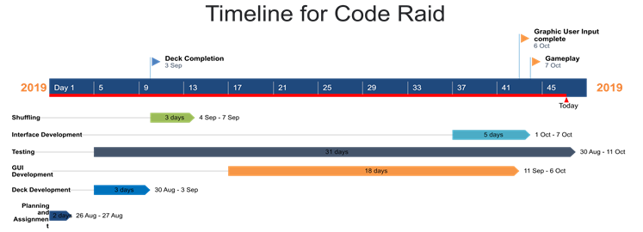

# References

Arneson, E., 2019. *Learn to Play the Children's Card Game, War.* [Online]   
Available at: https://www.thesprucecrafts.com/war-card-game-rules-411145  
[Accessed 26 August 2019].

C, N., 2017. *The History of Casino War.* [Online]   
Available at: https://www.alljackpotscasino.com/blog/history-casino-war/

C, N., 2017. *The History of Casino War.* [Online]   
Available at: https://www.alljackpotscasino.com/blog/history-casino-war/

Rigal, B. & Sharif, O., 2019. *How to Play War.* [Online]   
Available at: https://www.dummies.com/games/card-games/childrens-games/how-to-play-war/  
[Accessed 26 August 2019].